Make notes about use case and sequence diagrams and in relation to our project(individual projects)develop diagrams for the functional components

Submission

Create a github repository

And submit the github like On the google doc- link soon to be used

**The project is a chat application with a Name “ LINKUP”**

Use Case: A chat application(**LINK UP**) allows users to communicate with each other in real time.

Actors:

User: Can send and receive messages, create groups, and manage contacts.

Admin: Can manage users, monitor chats, and handle system maintenance.

System: Handles message delivery, notifications, and data storage.

Use Cases:

Login: User enters credentials to access the application.

Create Account: User registers with the application.

Search for Users: User searches for other users to chat with.

Start Chat: User initiates a chat with another user.

Create Group: User creates a new chat group.

Send Message: User sends a message to another user.

Receive Message: User receives a message from another user.

View Chat History: User views previous chat messages.

Add/Remove User: Admin adds or removes contacts from their contact list.

Monitor Chats: Admin monitors ongoing chats for compliance.

Search Messages: User searches for specific messages or users.

A sequence diagram is a type of interaction diagram because it describes how—and in what order—a group of objects works together. These diagrams are used by software developers and business professionals to understand requirements for a new system or to document an existing process

**A Class Diagram Of A Chat Application**

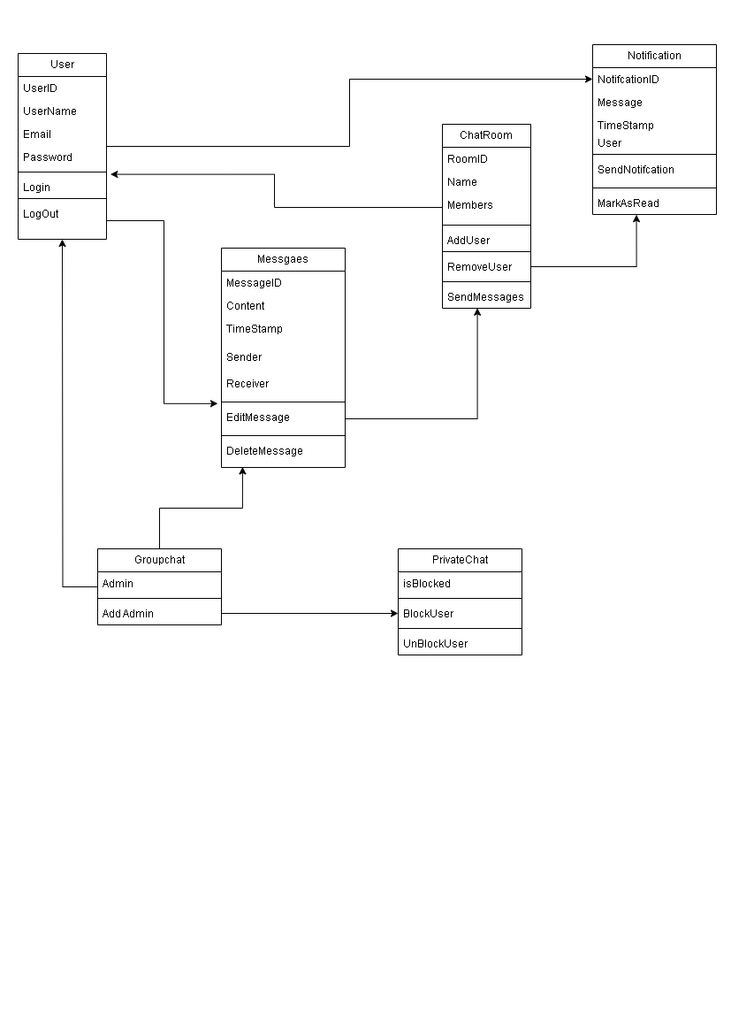

A Sequence Diagram of A chat Application

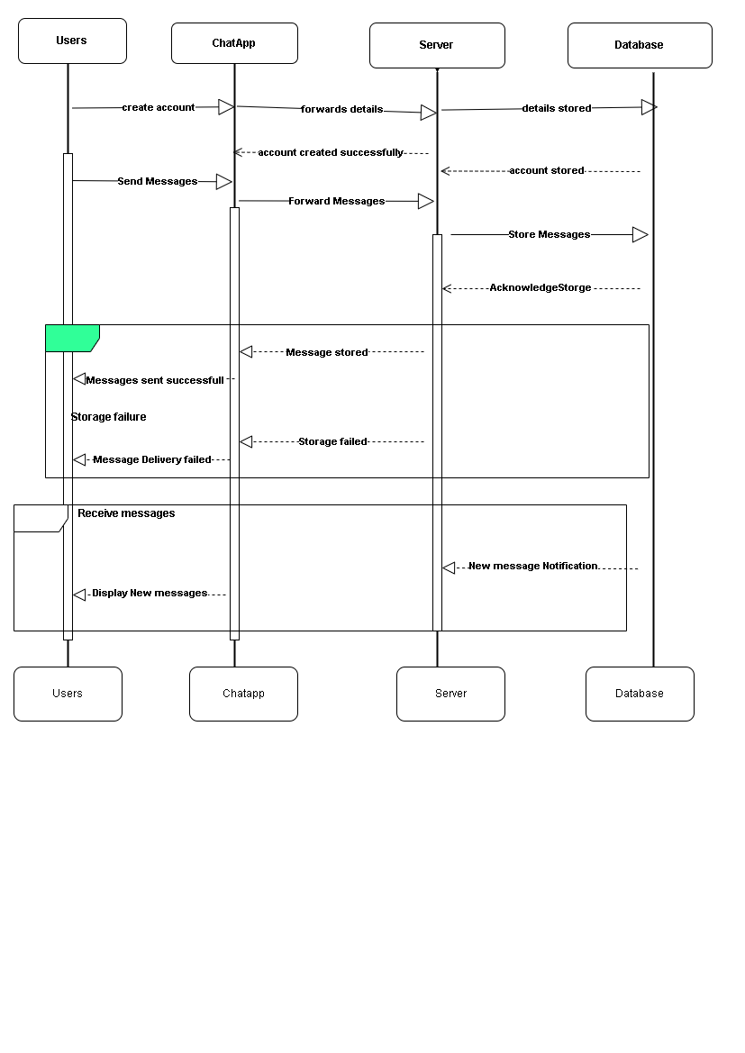

A Class Digram Of A Chat Application

